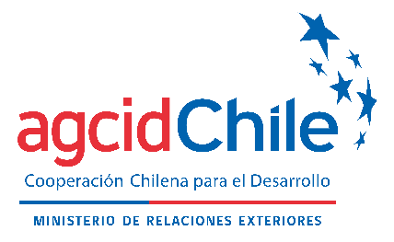 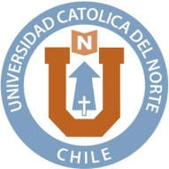

**3rd INTERNATIONAL COURSE** **“AQUACULTURE PRODUCTION TECHNOLOGIES AND THE USE OF AQUACULTURE AND FISHERY BY-PRODUCTS”**

**ONLINE EDITION**

**2024**

Call for Applications available at: <https://www.agci.cl>

Chilean International Cooperation Agency for Development │ AGCID

**OVERVIEW**

1. **PROGRAMME NAME**

The 3rd International Course “Aquaculture Production Technologies and the Use of Aquaculture and Fishery By-Products”, taught by the Department of Aquaculture of the Faculty of Marine Sciences, Universidad Católica del Norte (UCN).

1. **CHILE – AFRICA INTERNATIONAL COOPERATION**

This third edition of the International Course is part of Chile's international cooperation programme with African countries to train high-quality human capital within the framework of the Nelson Mandela Scholarship Programme, offering training on different subjects for development and innovation in relevant thematic areas. The programme dates back to 2015 and has since offered different options for training human capital, ranging from short programmes to scholarships for Master’s studies with financing and benefits for up to 24 months.

To promote relations with African countries, the Chilean International Cooperation Agency for Development (AGCID) has designed a Development Cooperation Strategy directed at the region. Within the framework of this action, it has identified countries that are interested in receiving cooperation in aquaculture matters, with the additional possibility of carrying out complementary activities with specialists from Costa Rica and South Africa, as potential interested partners in this collaborative cooperation, boosting development and benefiting the recipient countries.

AGCID has successfully developed and implemented several international courses on aquaculture technologies with countries from Latin America, the Caribbean, Asia and Africa. It is along these lines that Chile will offer this International Course in partnership with Universidad Católica del Norte (UCN), which is renowned for its work in marine and inland aquaculture, for the benefit of African countries.

Four different countries – Algeria, Ethiopia, Kenya and Mozambique – participated in the first edition of the International Course (2022), and participation increased to seven countries – Algeria, Ethiopia, Kenya, Morrocco, Mozambique, Namibia and Tanzania – for the second edition (2023), in an indication of the positive response it has received. Thanks to the course, connections have been formed between participating professionals from each country, who have worked together and exchanged their experiences in developing different projects. More than 94% of participants say that the content taught in the first and second editions of the International Course were relevant to their personal needs, and 89% consider the information taught by the experts at the International Course to be very appropriate. Finally, 78% of participants reported that the length of the course (3 weeks) was appropriate.

1. **BACKGROUND**

African coastal waters are home to some of the world’s most abundant fishing grounds and have great development potential for aquaculture. From a geopolitical perspective, part of Africa is located in a Mediterranean area (North Africa) and its further progress is supported by its proximity to Europe and Asia, as is shown by the significant growth of aquaculture in Europe, where production tripled between 2007 and 2018. Then there is West Africa, where approximately 25% of jobs are linked to fisheries. However, in Sub-Saharan Africa, both fisheries and aquaculture are subject to more complex governance due to the limited institutional capacity to drive the changes necessary for sustainable growth. (FAO 2020a).

In this sense, it is important to note that improvements in infrastructure are necessary to develop the activity and make it commercially viable (roads, warehouses, cold chains, markets). Channels for internal sales as well as for exports beyond the communities dedicated to the activity also need to be improved. Finally, the countries of the African continent and the Sub-Saharan region in particular are in need of a greater number of experts with whom they can interact. An in-depth study is needed in order to analyse the inherent biological needs (pathological, physiological, nutritional and otherwise) of each species, particularly those that are endemic to Africa.

The countries considered for this third Call are: Algeria, Ethiopia, Ghana, Kenya, Morocco, Mozambique, Namibia, South Africa and Tanzania. The aquaculture development of each of these countries may differ depending on the species they farm and the industrialisation they have developed with their production.

For this course, the African continent has been sub-divided into two main areas: Northern or Mediterranean Africa (Algeria and Morocco) and Sub-Saharan Africa (Ethiopia, Ghana, Kenya, Mozambique, Namibia, South Africa and Tanzania). Tanzania and Ghana are the leading aquaculture producers among the group of invited countries. In 2021, Tanzania achieved 106,482 MT of annual production, while Ghana produced 89,380 MT (see Figure 1).

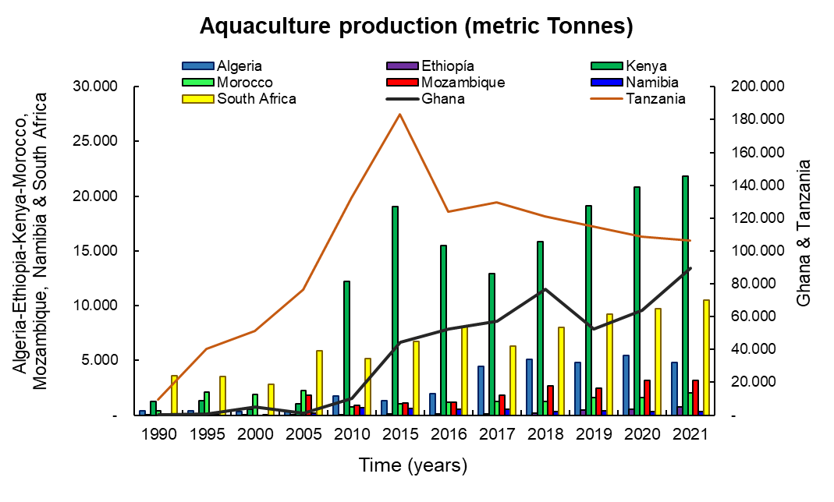

Figure 1 Aquaculture production of the African countries invited to participate in the course. The data for Ghana and Tanzania are represented on the right axis (lines) due to the larger size of their annual productions (World Bank, 2023).

The annual productions of the remaining invited countries range from less than 25,000 MT (Kenya and South Africa) to the lowest production values of 740 and 321 in Ethiopia and Namibia, respectively, in 2021. The countries of Sub-Saharan Africa are already home to a population of nearly 1.13 billion (World Bank, 2023).

With a growing population, it is expected the demand for food will increase in the coming years. Mozambique and Morocco have shown similar production rates between 2011 and 2021, with productions of 3,200 and 2,000 MT respectively in 2021. In some countries of Sub-Saharan Africa, however, consumption of seafood products does not exceed 2 kg per capita per year (Ethiopia and Lesotho) (FAO, 2020).

Annex 1 of this report contains a summary of the aquaculture production characteristics for each country.

1. **PROGRAMME OBJECTIVES**

This third edition of the course is aimed at civil servants (both technical and professional) as well as researchers from universities and/or research and development centres in the African countries invited to participate.

The International Course aims to provide participants with the technological tools for farming aquatic resources and using aquaculture and fisheries by-products, in the hope aquaculture development will contribute to reducing hunger and poverty. At the same time, it seeks to ensure aquaculture production is sustainable through the use of aquaculture and fisheries by-product management models, and by taking into account the Blue Circular Economy. The course is aligned with the Sustainable Development Goals of the 2030 Agenda, including: Goal 2 (Zero Hunger), Goal 12 (Responsible Consumption and Production), Goal 13 (Climate Action), Goal 14 (Life Below Water), Goal 15 (Life On Land) and Goal 17 (Partnerships for the Goals).

Like the 2022 and 2023 editions, the International Course will be held online using the UCN Virtual Campus Platform, which will allow participants to receive feedback and the support of a team of educators specialised in the subject matter.

1. **EXPECTED OUTCOMES**

The International Course will develop the technical and theoretical skills of the scholarship recipients as they learn about aquaculture and hydrobiology resources and uses of the fisheries and aquaculture by-products generated in the countries involved through learning about the experiences of Chile, Costa Rica and South Africa in the matter and within the framework of sustainable development, the applicable rules and regulations, and how to ensure the sustainability of the harvested resources, taking into account the circular economy and the SDGs of the 2030 Agenda, thus generating a community of learning with the beneficiary countries.

1. **MAIN REASONS TO PARTICIPATE IN THE COURSE**

* To gain a better understanding of the importance of applying new technologies in marine and freshwater aquaculture harvesting.
* To recognize the main challenges in the use of aquaculture and fisheries by-products.
* To learn better ways to use aquaculture and fisheries waste in a sustainable manner for African countries.
* To hear of new experiences in re-using aquaculture and fisheries products and/or by-products.
* To establish contact with a network of aquaculture professionals in order to exchange experiences regarding fish farming technologies and the use of by-products in a circular economy.

1. **PROGRAMME DESCRIPTION**

The International Course will be held in a remote format using the UCN Virtual Campus Platform, where participants will have access to the academic content.

The Course is divided into two modules, each of which will be divided into additional sub-modules.

Each module consists of synchronous presentations held in real-time as well as lecture material, and/or recorded videos which can be reviewed asynchronously by course participants. The material for the synchronous presentations will be uploaded to the virtual platform ahead of the live sessions for review by the participants. The synchronous live sessions will be led by the teacher for that corresponding module, who will present the subject matter and address any doubts the participants may have with respect to the material they reviewed in advance.

**CONTENTS**

**MODULE I: FISH FARMING TECHNOLOGIES:**

SUB-MODULE 1: Marine fish farming technologies

* + Marine fish farming and biology
  + Inland fish farming and biology
  + Multi-trophic cultures
  + Bioeconomics in aquaculture
  + Recirculation and aquaponics technologies
  + Techniques for handling and cultivating rotifers
  + Artemia production and enrichment

SUB-MODULE 2: Mollusc and shellfish farming technologies

* Technologies for farming oysters and scallops in suspension systems
* Land and sea-based abalone farming technologies
* Technologies for shrimp farming in coastal areas

SUB-MODULE 3: Microalgae and macroalgae farming technologies

* + Innovative techniques for the management and mass cultivation of microalgae
  + Management of indigenous microalgae strains for animal production
  + Traditional and innovative techniques for the cultivation of macroalgae
  + Indigenous macroalgae in intensive or extensive cultivation systems.

SUB-MODULE 4: Sanitary aspects of aquaculture production

* + Sanitary control in aquaculture facilities
  + Common diseases in fish farming
  + Sanitary aspects of processing plants

**MODULE II: USE OF FISHERY AND AQUACULTURE BY-PRODUCTS**

SUB-MODULE 1: The fisheries and aquaculture circular economy

* Use of aquaculture and fisheries waste and by-products Applicable technologies for the re-use of fisheries and aquaculture by-products.
* Added value of hydrobiology waste
* Using fishery waste to produce biofertilisers for agriculture

SUB-MODULE 2: Rules and regulations for sustainable aquaculture

* Regulations in Chile for the use of aquaculture and fisheries by-products
* Regulations in Costa Rica for the use of aquaculture and fisheries by-products
* Regulations in South Africa for the use of aquaculture and fisheries by-products

SUB-MODULE 3: Financing for sustainable aquaculture

* International entities for financing aquaculture (FAO)
* Examples of a circular economy in aquaculture

**Proposed schedule (1) for the 3rd Edition of the International Course *“Aquaculture Production Technologies and the Use of Aquaculture and Fishery By-Products”***

|  |  |  |  |  |
| --- | --- | --- | --- | --- |
| **DATE** | **Chilean time (GMT-3)** | **Title of presentation** | **Speaker** | **Institution** |
| **Monday 25/11/24** | 09:00 - 10:00 Synchronous class | Marine fish farming technologies | Héctor Flores | UCN |
| 10:00 - 11:00 Synchronous class | Inland fish farming technologies | Edison Serrano | UCN |
| **Tuesday 26/11/24** | 09:00 - 10:00 Synchronous class | Supplementary feeds for fish and other organisms | Marcia Oliva | UCN |
| 10:00 - 11:00 Synchronous class | Inland fish farming: Tilapia | Aldo Fernández | Consultant |
| **Wednesday 27/11/24** | 09:00 - 10:00 Synchronous class | Tilapia Farming in Sub-Saharan Africa | Khalid Salie | SU - South Africa |
| 10:00 - 11:00 Synchronous class | Physiological adaptations for improvements in fish farming | Claudio Álvarez | UCN |
| **Thursday 28/11/24** | 09:00 - 10:00 Synchronous class | Multi-trophic marine cultures | German Lira | UCN |
| 10:00 - 11:00 Synchronous class | Bioeconomics of fish farming | Ángel Herrera | UNA - Costa Rica |
| **Friday 29/11/24** | 09:00 - 10:00 Synchronous class | Recirculation and aquaponics technologies | German Merino | UCN |
| 10:00 - 11:00 Synchronous class | Aquaponics and social enterprises: South African case study | Henk Stander | SU - South Africa. |

|  |  |  |  |  |
| --- | --- | --- | --- | --- |
| **DATE** | **Time** | **Title of presentation** | **Speaker** | **Institution** |
| **Monday 02/12/24** | 09:00 - 10:00 Synchronous class | Mollusc (bivalve) farming technologies | Luis Pereira | UCN |
| 10:00 - 11:00 Synchronous class | Mollusc (abalone) farming technologies | Pete Britz | RU - South Africa. |
| 11:00 - 12:00 Synchronous class | Shellfish farming technologies (Crustaceans) | Cristina Morales | UCN |
| **Tuesday 03/12/24** | 09:00 - 10:00 Synchronous class | Microalgae farming technologies | Gonzalo Álvarez | UCN |
| 10:00 - 11:00 Synchronous class | Macroalgae farming technologies | Fadia Tala | UCN |
| **Wednesday 04/12/24** | 09:00 - 09:40 Synchronous Presentation | *Presentation of the state of the art by country: COUNTRIES 1 & 2* | Evaluations | |
| 09:40 - 10:20 Synchronous Presentation | *Presentation of the state of the art by country: COUNTRIES 3 & 4* | Evaluation | |
| 10:20 - 11:00 Synchronous Presentation | *Presentation of the state of the art by country: COUNTRIES 5 & 6* | Evaluation | |
| 11:00 - 11:20 Synchronous Presentation | *Presentation of the state of the art by country: COUNTRIES 7 & 8* | Evaluation | |
| **Thursday 05/12/24** | 09:00 - 10:00 Synchronous class | Rules and regulations for sustainable aquaculture in Chile | Marisol Álvarez | SUBPESCA (Undersecretariat of Fisheries and Aquaculture) |
| 10:00 - 11:00 Synchronous class | Mariculture regulations: Costa Rica | Jonathan Chacón | UNA - Costa Rica |
| **Friday 06/12/24** | 09:00 - 10:00 Synchronous class | Diseases in fish farming | Edison Serrano | UCN |
| 10:00 - 11:00 Synchronous class | Sanitary aspects that require monitoring in aquaculture facilities | Rodrigo Rojas | UCN |
| 11:00 - 12:00 Synchronous class | Sanitary aspects of seafood processing plants | Ma Isabel Agüero | Consultant |

|  |  |  |  |  |
| --- | --- | --- | --- | --- |
| **DATE** | **Time** | **Title of presentation** | **Speaker** | **Institution** |
| **Monday 09/12/24** | 09:00 - 10:00 Synchronous class | Technologies for the re-use of fisheries and aquaculture waste I | Rodrigo Poblete | UCN |
| 10:00 - 11:00 Synchronous class | Technologies for the re-use of fisheries and aquaculture waste II | Begoña Peceño | UCN |
| **Tuesday 10/12/24** | 09:00 - 10:00 Synchronous class | Circular Economy and water remediation in freshwater and marine aquaculture systems | Cliff Jones | RU - South Africa. |
| 10:00 - 11:00 Synchronous class | Algal polysaccharides as a strategy for addressing agricultural challenges | Nancy Chandia | UCN |
| **Wednesday 11/12/24** | 09:00 - 10:00 Synchronous class | Added value of hydrobiology waste I | Ronny Martínez | ULS |
| 10:00 - 11:00 Synchronous class | Added value of hydrobiology waste II | Vilbett Briones | ULS |
| **Thursday 12/12/24** | 09:00 - 10:00 Synchronous class | Use of aquaculture and fishery by-products in aquaculture feeds | Pedro Toledo | UCN |
| 10:00 - 11:00 Synchronous class | FAO Funds for Aquaculture Innovation Projects | Alessandro Lovatelli | FAO |
| **Friday 13/12/24** | 09:00 - 09:40 Synchronous Presentation | *Presentation of Final Projects: COUNTRIES 1 & 2* | Evaluation | |
| 09:40 - 10:20 Synchronous Presentation | *Presentation of Final Projects: COUNTRIES 3 & 4* | Evaluation | |
| 10:20 - 11:00 Synchronous Presentation | *Presentation of Final Projects: COUNTRIES 5 & 6* | Evaluation | |
| 11:00 - 11:20 Synchronous Presentation | *Presentation of Final Projects: COUNTRIES 7 & 8* | Evaluation | |

_______________________________________________________________________

(1) This schedule may undergo some changes in programming in the event of scheduling conflicts of the presenters.

1. **TEACHING STAFF**

|  |  |
| --- | --- |
| **Universidad Católica del Norte Academic Staff** | |
| Toledo Agüero, Pedro | Animal Nutrition |
| Merino Araneda, Germán | Aquaculture engineering and RAS operations |
| Lira, German | Marine mollusc production |
| Peceño Capilla, Begoña | Circular economy and water re-use |
| Alvarez Vergara, Gonzalo | Microalgae cultivation and biotoxins |
| Tala Gonzalez, Fadia | Macroalgae cultivation and physiology |
| Pereira Chavez, Luis | Mollusc farming |
| Poblete Chávez, Rodrigo | Use of aquaculture and fisheries waste |
| Morales Suazo, Maria Cristina | Shrimp farming |
| Flores Gatica, Hector | Marine fish farming |
| Serrano Gutierrez, Edison | Processes and mechanisms of animal feed production |
| Rojas, Rodrigo | Microbiology in aquaculture |
| Oliva Arriagada, Marcia | Fish larvae farming and supplementary feeds |

**Other confirmed and/or to be confirmed speakers**

|  |  |
| --- | --- |
| Dr. Peter Britz, Rhodes University (South Africa) | |
| Dr. Cliff Jones, Rhodes University (South Africa) |
| Dr Khalid Salie, Stellenbosch University (South Africa) |
| MSc. Henk Stander, Stellenbosch University (South Africa) |
| Dr. Angel Herrera, National University of Costa Rica (Costa Rica) |
| Dr. Jonathan Chacón, Parque Marino del Pacifico (Costa Rica) |
| Mrs. Marisol Alvarez, Undersecretary Fisheries Office (Chile) |
| Dr. Alessandro Lovatelli, FAO officer Directive (Italy) |
| Mrs. María Isabel Agüero, Independent Consultant – Plant Processes (Chile) |
| Mr. Aldo Fernández, Independent Consultant – Tilapia (Chile) |
| Dr. Ronny Martinez, La Serena University (Department of Microbiology) (Chile) |
| Dr. Vilbett Briones, La Serena University (Department of Food Engineering) (Chile) |

**IX. DURATION**

The International Course will take place between November 25 and December 13, 2024 and will be held in a 100% online format.

The academic course requires a dedication of approximately 30 theory hours (synchronous presentations, capsules, and asynchronous videos) plus 30 hours of individual work (consisting of a project applicable to the participant’s country of origin, which will be presented as an original project proposal to be evaluated during the course), for a total of approximately 60 hours.

**X. METODOLOGY**

The International Course will be held online using the Zoom platform together with the Universidad Católica del Norte (UCN) Virtual Platform, which will host all of the information needed by the participants and through which they will have access to all the course contents (presentations, supplementary material from publications on topics covered in the course, videos related to each topic). It's necessary that participants dedicate extra time to reviewing and reading the bibliographic material provided to them, as it forms an integral part of the course..

The daily synchronous sessions will be held in the morning (from 09:00 a.m. Chilean time, GMT-3). (2)

Each module consists of synchronous presentations (in real-time) and recorded materials designed specifically for the course (how-to videos). The synchronous sessions will be led by the teacher for the corresponding subject, who will address any doubts participants may have concerning about the material they reviewed before entering the session.

(2) The synchronous presentations will take place at 9:00 a.m. Chilean time (GMT-3), equivalent to 12:00 p.m. in Ghana (GMT 0), 01:00 p.m. in Morocco, Algeria and Namibia (GMT+1), 02:00 p.m. in South Africa and Mozambique (GMT+2), and 03:00 p.m. in Ethiopia, Kenya and Tanzania (GMT+3).

To ensure participants learn the course material, each scholarship recipient must attend 75% of the synchronous presentations and study the documentation, guidelines, bibliography or videos provided prior to each session. The synchronous sessions will be recorded for later review by the participants and uploaded to the UCN Virtual Campus Platform.

**XI. LANGUAGE**

The official language of the course is English and therefore applicants must demonstrate an intermediate or higher level of fluency in the language to be able to obtain a scholarship for the course. However, the presentations will be delivered in Spanish (with simultaneous translation to English) and in English.

**XII. EVALUATION SYSTEM**

During the course, there will be two evaluations that aim to encourage collaboration between participants.

For the first evaluation, participants will be given a time frame of at least 3 weeks to prepare a presentation giving an overview of the state of the art of aquaculture in each country. The participants will present and/or share their work with all course participants on a date to be defined.

For the second evaluation, each group will prepare a project proposal to be developed by the participants at their beneficiary organization or sponsoring institution.

Thus, to pass the course, each participant must fulfill the following three requirements:

1. A minimum attendance of 75% of the synchronous presentations, which the course administration will be check daily.
2. Preparation and group presentation of aquaculture state of the art in each participant’s country of origin.
3. Preparation of a group project on one of the issues addressed in the course based on the state of the art in each country.

Participants must receive a grade of more than 60% on each presentation (the grading scale ranges from 1 to 100%).

Those who meet these academic requirements will receive a formal digital certificate accrediting their successful participation and passing grade for the course from the Universidad Católica del Norte.

**XIII. SCHOLARSHIPS AND FUNDING**

If the professionals from the invited countries who are selected to participate in the 3rd Edition of the International Course successfully meet the requirements to pass the course, they will receive a scholarship that includes the costs of participating in the International Course (tuition and fees) as well as the digital certificate

**XIV. APPLICATION REQUIREMENTS**

# The course is aimed at civil servants and professionals residing in Algeria, Morocco, Ghana, Ethiopia, Kenya, Mozambique, Namibia, South Africa and Tanzania. Applicants must:

# Hold a professional degree certificate, bachelor’s degree, or other academic degree granted by a university in aquaculture, marine biology, fisheries, agricultural sciences, or a university degree in a related discipline.

# Have an intermediate level of reading and oral comprehension in English, a sufficient command of the language to understand it in written form, or at a level that allows for the reading of articles.

* Up-to-date curriculum vitae (2 pages maximum).
* At least 1 year of work experience.
* Certificate of support from the sponsoring institution (Ministry, University or Institute) in their country of origin.
* You must have adequate and efficient internet access to connect to the meetings and presentations held via Zoom or another platform to be determined.
* Must be a citizen of one of the countries invited to the course and reside in that country.

Candidates must submit their application to the Chilean Embassy in their respective country (see Focal Points, Annex IV) for it to be officially registered. Applications sent directly without being formally registered via the corresponding Focal Point will not be considered for selection.

The stages and relevant dates of the Call for Scholarship Applications for this international course are as follows:

|  |  |
| --- | --- |
| **Stage** | **Dates** |
| Closing date for the Call *(for applicants)* | 05 November 2024 |
| Pre-selection of candidates and submission of applications to the Scholarship Platform *(for Focal Point)* | 06 November 2024 |
| Selection Committee | 11 – 13 November, 2024 |
| Publication of results and notification of selected applicants | 15 November 2024 |

**Each Embassy of Chile will set an application submission deadline. It is therefore the responsibility of each applicant to directly consult with the Focal Point in their respective country (Annex IV) regarding the closing date for the Call for Applications. Closing dates may vary from one country to another.**

The Embassy of Chile in each country must upload its pre-selection of applicants (there is no quota per country) to the Chilean International Cooperation Agency for Development (AGCID) Scholarship Platform by no later than November 06, 2024, 23:59 Chilean time.

The final deadline for the receipt of applications is **November** **06 2024, without exception. However, the Embassy of Chile in each country may close the Call for Applications earlier.** Applicants must therefore confirm the closing date for applications in their country of origin, using the contact details found in Annex IV.

NOTE:

* No incomplete, illegible, or late applications will be considered.
* Only applications officially submitted via the Embassy of Chile will be considered.
* Applications submitted directly by the applicant will not be considered.
* Applicants must thoroughly read the Call for Applications, including all its requirements, the application process, and submit the attached documents.

The information provided in the application form and its respective annexes are considered a sworn declaration and, therefore, in the event falsified, adulterated, inaccurate or misleading information is presented for the purpose of receiving a scholarship, the applicant shall assume the respective administrative, civil and criminal sanctions, in accordance with the regulations of their country of origin.

Moreover, the applicant will be indefinitely disqualified from applying to future Calls for Applications, and such circumstance will be reported to the scholarship committee.

1. **SELECTION**

The selection will be made by a technical committee composed of AGCID and the Universidad Católica del Norte (UCN) members. This same committee may also evaluate the appropriateness of including additional experts in the field of aquaculture and fisheries in the process.

The results of the selection will be publish on **15 November 2024, on the AGCID website, www.agci.cl**, for the information of all interested parties.

The course administrators will contact each selected applicant via email, using the contact information provided in the Application Form, to notify them of their selection and directly coordinate all arrangements for their participation.

Important: Only those applicants selected for the scholarship will be notified. Once they have confirmed acceptance of the scholarship, they will be sent a guide with the corresponding instructions and procedures that will need to be followed.

**The results concerning those awarded scholarships are the sole decision of the Selection Committee, and the decision cannot be appealed.**

**XVI. TOTAL NUMBER OF PARTICIPANTS**

A total of 30 places are available.

**XVII. SELECTION PROCESS**

The countries invited to participate in the course shall nominate candidates. Candidates must submit the following documentation to the Embassy of Chile (see Focal Points, Annex IV):

1. Application form (Annex I), with all of the requested information duly completed and signed by the applicant as well as by his/her direct supervisor.
2. Letter of commintment (Annex II).
3. Letter from labour certificate (Annex III)
4. Degree certificate (simple photocopy).

**XVIII. CONTACT INFORMATION**

**Department of Aquaculture, Faculty of Marine Sciences, Universidad Católica del Norte (UCN) – Chile**

Pedro Toledo

Phone: (+56 51) 209765

Email: [ptoledo@ucn.cl](mailto:ptoledo@ucn.cl)

**Chilean International Cooperation Agency for Development (AGCID)**

Teatinos 180, Piso 8. Santiago, Chile

(+56 2) 2827 5700

Email: [agencia@agci.gob.cl](mailto:agencia@agci.gob.cl)

**COLLABORATING ORGANISATIONS**

  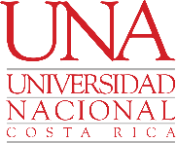

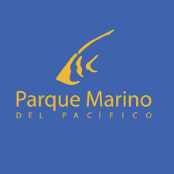 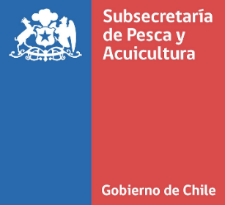 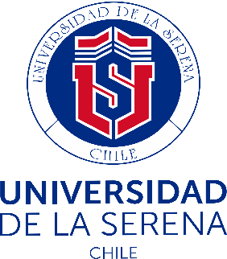

**ANEXO 1**

**INVITED COUNTRY PROFILES**

1. **Algeria** 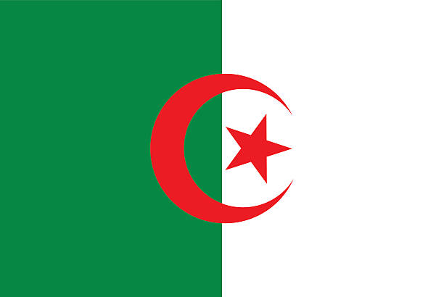

Aquaculture initially developed in the country at the end of the 19th century, but disappeared due to lack of support. Algeria is home to many important rivers but has just one coastal lagoon, which limits the potential for establishing aquaculture at natural sites. In the 1980s, two government-run aquaculture centres were established under the Ministry of Agriculture: the Lake Mellah fish farm (865 ha of brackish water) and Mazafran Station (Bruno, 1987).

The Lake Mellah fish farm has the potential to become Algeria’s first marine fish hatchery. It has received substantial support from MEDRAP (Mediterranean Regional Aquaculture Project) for the designs and plans for the hatchery and for a sea bass fattening unit. ENAPECHE (the National Fishing Company) controls the lake. The production of molluscs (oysters and mussels) remains low, with about 10 metric tonnes annually (MTPA) of oysters and 8 MTPA of mussels in 1984 (Bruno, 1987).

In Mazafran, a small centre is responsible for developing freshwater aquaculture, including restocking the lake. Between 1976 and 1978, Algeria entered a cooperation agreement with the People's Republic of China. The cooperation programme included the reproduction and pre-fattening of carp for restocking purposes.

With regard to the MEDRAP programme, the Algerian authorities had envisioned achieving a production of 175,000 MTPA of fish and seafood in general by 2000, however, statistics show production did not surpass 351 MTPA in the decade from 2000–2009 (World Bank, 2021).

There are several aquaculture systems being developed in arid zones of Algeria. in the Ouargla district, four types of farms have been established: a) a fish farm using a flow-through system for intensive farming of North African catfish (*Clarias gariepinus*) with annual production of 300 tonnes (Corner et al., 2020); b) a 20 ha integrated agro-aquaculture farm that uses groundwater resources to raise Nile tilapia (*Oreochromis niloticus*) and crops (tomatoes, cucumbers, dates and olives); c) a government-owned aquaculture facility created with the cooperation of the Korean International Cooperation Agency (KOICA) for shrimp farming (*Penaeus vannamei*); and, lastly d) a farm dedicated to cultivating the *Spirulina* genus of microalgae (Corner et al., 2020).

The Ministry of Fisheries and Fishery Resources of Algeria has designed a strategic plan for the sustainable development of marine aquaculture (MPRH 2998) applied to molluscs, which is currently being implemented. The programme aims to establish 56 new Mediterranean mussel (*Mytilus galloprovincialis*) farms along the Algerian coast, which would increase production from less than 150 MT in 2013 to 7,600 MT in 2025 (Lourguioui *et al.,* 2017).

Aquaculture using unconventional water sources has been developing slowly in Algeria since 2008. There are currently about 600 fish farmers assessing the potential for development and who are generally operating on a small scale while developing techniques and approaches for aquaculture in arid zones, though there are also some operations active at a larger commercial scale (Hartani, 2020). 2017 production was estimated at approximately 5,000 MT of mainly tilapia and some catfish and carp, integrated with more conventional agricultural crops such as date palm, grains and produce. Developing extensive and semi-intensive systems has been further hampered by poor understanding and training in production and cultivation practices, although there have been increases in peer-to-peer training and some producers have been able to benefit from training opportunities abroad (Hartani, 2020).

Aquaculture-related institutions in Algeria include:

* Ministry of Fisheries and Fishery Resources
* National School of Marine Science and Coastal Planning
* University of El Tarf (Marine Science and Oceanography).
* Faculty of Natural and Life Sciences, Université Abdelhamid, Algeria.
* Algerian National Centre for Research and Development in Fisheries and Aquaculture (CNRDPA)
* National Office of Statistics (ONS)

f) **Ethiopia** 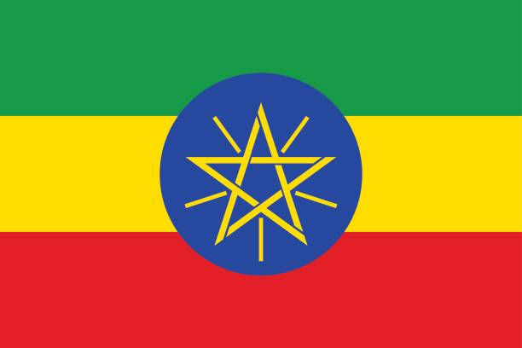

Ethiopia has a considerable number of freshwater systems – including lakes, reservoirs, rivers, ponds and wetlands – that support the development of the aquaculture sector. The country has twelve river basins with an annual runoff volume estimated at 122 billion m3. The country is also home to 11 freshwater lakes and 9 saline lakes, 12 major wetlands and many crater lakes (Abera, 2017). The freshwater systems support a considerable number of fisheries and there is nutritional and economic potential. However, catch and keep fishing is unregulated and poorly managed, which has led to the overexploitation of resources, degradation of biological diversity and a reduction in fish supply and incomes (Natea, 2019).

Aquaculture in Ethiopia first took the shape of extensive aquaculture (Yalew et al., 2015) to restock and improve artificial lakes, reservoirs and small bodies of water. In the early 2000s, more than 2.5 million fingerlings were released, mainly of Nile tilapia (*Oreochromis niloticus*), Redbelly tilapia (*Coptodon zillii*), Common carp (*Cyprinus carpio*) and Crucian carp (*Carassius carassius*). Semi-industrial aquaculture practices are at a very early stage of development. Candidate species for aquaculture include tilapia (*Oreochromis niloticus*) and African catfish (*Clarias* sp.), though the aquaculture possibilities for other species present in freshwater rivers and reservoirs are yet to be explored (Natea, 2019).

Some trials are currently underway to increase fish production and integrate more producers in land-based areas in different parts of the country. Several institutes, such as the Sebeta Fishery and Aquatic Life Research Centre, the Batu Fishery Research Centre and the Bahir Dar Fisheries and Other Aquatic Life Research Centre are beginning artificial propagation trials in production laboratories and hatcheries. In general, aquaculture in Ethiopia is poorly developed due to a lack of support, dissemination, training of human capital, shortage of technical expertise, lack of fingerlings, lack of funding, and low levels of research and institutional capacity (Natea, 2019).

Aquaculture-related institutions include:

• Sebeta Fisheries and Aquatic Life Research Centre

• Batu Fishery Research Centre

• Bahir Dar Fisheries and other Aquatic Life Research Centre

• Addis Ababa University

• National Fish and other Aquatic Life Research Centre

• Ziway Fisheries Resource Research Centre

• Ambo University.

d) **Ghana** 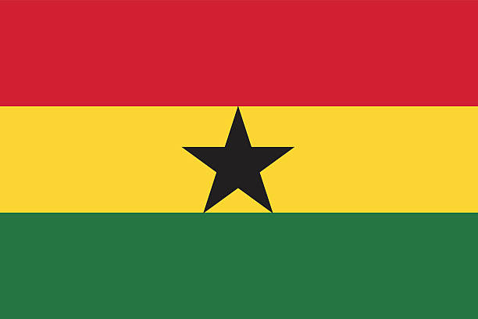

Aquaculture in Ghana has experienced substantial growth in recent years, thanks to a fisheries programme funded by the government and the World Bank through the Ministry of Fisheries and Aquaculture Development (MoFAD). National aquaculture production grew from 32,512 MTPA in 2013 to 52,470.49 MTPA in 2016, a 61.3 percent increase.

There are two cage culture companies in Ghana: Crystal Lake Fish Ltd. and Tropo Farms Ltd. Both are located at Volta Lake, one of the largest artificial lakes in the world (Blow and Leonard, 2008). Both Volta Lake and the Bosomtwi and Pra rivers, which have also been instrumental in fish production, have specific issues, ranging from pollution due to mining to falling water levels that compromise fishing. Faced with these problems, aquaculture provides an excellent opportunity to bridge the increasing gap between fish supply and demand (Rurangwa et al., 2015).

Fish farming in Ghana is concentrated primarily on three species: tilapia (*Oreochromis niloticus*), African catfish (*Clarias gariepinus*) and African arowana (*Heterotis niloticus*). There have been attempts to introduce other species, including: *Oreochromis macrochir*, the common carp (*Cyprinus carpio*) and Asian tiger shrimp (*Penaues monodon*). Efforts to introduce *Penaues monodon* have focused on brackish waters, however, no direct efforts have been made in marine environments (Amenyogbe et al., 2015). Cultivation in Ghana makes use of ponds, pens, cages and raceways. Cages and raceways are costly in terms of the structures and costs of feeding compared to pens (Blow and Leonard, 2008). However, limited knowledge of modern aquaculture techniques, inadequate supplies of improved seed, the lack of a continuous direction for aquaculture policy and inadequate funding for research have created several challenges in terms of the management and production of Ghana’s aquaculture sector (Amenyogbe et al., 2018). In Ghana, the private sector dominates aquaculture. There are more than 2,000 local small-scale fish farmers in the country and foreign commercial cage aquaculture operations in the southern part of Volta Lake.

Aquaculture-related institutions include:

• WARFP (West African Regional Fisheries Programme)

• MoFAD (Ministry of Fisheries and Aquaculture Development)

• Kwame Nkrumah University of Science and Technology

• University of Ghana

• University of Cape Coast

• Kwadaso Agricultural Institute

e) **Kenya** 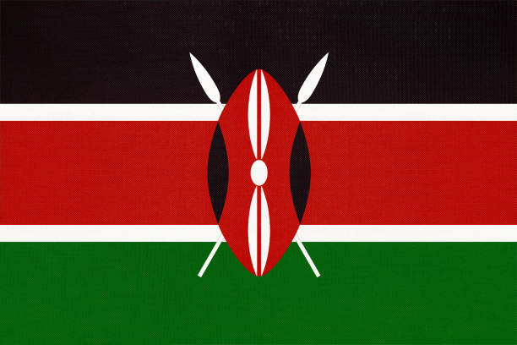

Kenya, located in Sub-Saharan Africa, has a vast network of water resources, including freshwater lakes and rivers and extensive ocean resources. Inland waters cover an area of 18,029 km2, while marine waters (including the Exclusive Economic Zone-EEZ) have a surface of 142,400 km2. Kenya has 640 km of coastline that supports a diverse fisheries production (KMFRI, 2017). Aquaculture has grown in the past decade, playing an important role in the national food basket. Freshwater fish account for about 98% of Kenya’s aquaculture production, as is exemplified by the growth in production between 2006 (4,218 MT) to a peak in 2014 (24,096 MT), representing 15% of total national fish production. Thanks to this rapid growth, Kenya is now Africa’s fourth largest aquaculture producer. The increased growth is due mainly to a government intervention in 2009 in the form of the Economic Stimulus Programme (ESP), which allocated 22 billion Kenyan shillings (approximately USD 283 million) between 2009 and 2012 to aquaculture in key sectors (KMFRI, 2017). However, the freshwater aquaculture sub-sector registered a decline in total production for the second consecutive year, dropping 24.8%, from 18.7 MT in 2015 to 14.95 MT in 2016. Nevertheless, Kenya has a much larger capacity for fish farming, with over 1.14 million hectares potentially available, which would allow for a production capacity of more than 11 million MTPA (KMFRI, 2017).

The main species cultivated in freshwater are Nile tilapia, which accounts for approximately 80 percent of production, and African catfish, which accounts for around 14 percent of production.

In marine aquaculture, the most commercially farmed fish is the milkfish (*Chanos chanos*), accounting for 90 percent of production, and the flathead grey mullet (*Mugil cephalus*), which accounts for about 10 percent of aquaculture production. Seafood farming on the Kenyan coast has focused primarily on shellfish, such as crab (*Scylla serrata*), Asian tiger shrimp (*Penaues monodon*) and brine shrimp (*Artemia salina*). There were experimental efforts to cultivate oysters in the Gazi and Funzi bays on the southern coast of Kenya; however, despite successful cultivation, it became unsustainable due to the lack of market linkages.

Aquaculture-related institutions include:

• KMFRI (Kenya Marine and Fisheries Research Institute)

• NARDTC (National Aquaculture Research Development and Training Centre)

• KWSTI (Kenya Wildlife Service Training Institute).

**Morocco** 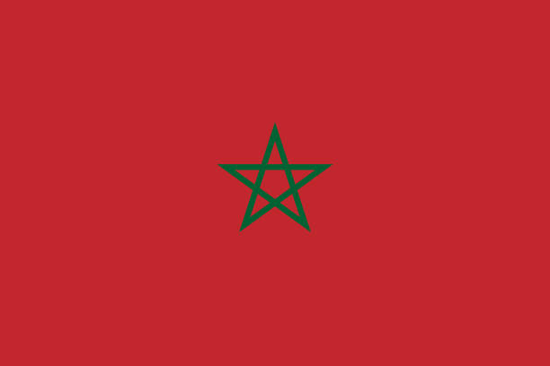

The history of aquaculture in Morocco dates back to the 1980s, when oyster cultivation first began in the lagoon at Oualidia. Intensive fish farming began in 1985 on the Mediterranean coast, initially at the Nador lagoon and later in M'diq. Production was mainly focused on sea bass, sea bream and oysters.

Ten years later, shellfish farming in the form of shrimp production was introduced at the mouth of the Moulouya river. Beginning in 2011, the creation of the National Agency for the Development of Aquaculture within the framework of the Halieutis Plan gave new impetus to the aquaculture sector.

In Morocco, marine aquaculture production is distributed as follows: molluscs (75%), algae (21.5%) and fish farming (3.5%). The most important species are:

a) Molluscs: oysters (*Crassostrea gigas*), clams (*Ruditapes decussatus*), mussels (*Mytilus galloprovincialis* and *Perna perna*), scallops (*Pecten maximus* and *Pecten jacobeus*) and abalones (*Haliotis tuberculata*).

b) Fish farming: seabass (*Dicentrarchus labrax*), bream (*Sparus aurata*), meagre (*Argyrosomus regius*) and turbot (*Psetta maxima*)

c) Algae: *Gracilaria sp.*

Aquaculture in Morocco has potential but it is poorly exploited compared to other countries in the North African region. In 2016, there were 21 aquaculture enterprises and a total of 470 tonnes of production (289 MT of oysters and 181 MT of fish). A shellfish farm dedicated to cultivating bivalve molluscs opened in early 2000 in Dakhla Bay.

In 2019, aquaculture production in Morocco rose to 895 MT; however, estimated potential is 380,000 MT, thanks to its 1,700 km of coastline and 13,385 ha available for development. The aquaculture sector’s development strategy aims to achieve a production of 200,000 MT by 2020 (Estrada, 2021).

Aquaculture-related institutions include:

• National Aquaculture Development Agency (Agence Nationale pour le Développement de l’Aquaculture, ANDA)

• National Institute of Fisheries Research (Institut National de Recherche Halieutique, INRH)

• National Food Safety Office (Office National de Sécurité Sanitaire des Produits Alimentaires, ONSSA)

• Department of Maritime Fisheries (Département de la Pêche Maritime, DPM)

• National Centre of Hydrobiology and Aquaculture (Centre National d'Hydrobiologie et de Pisciculture, CNHP)

**Mozambique** 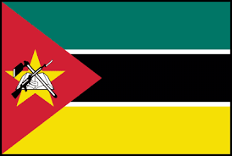

With a population of over 28 million inhabitants, Mozambique has 6,942 km of coastline and an Exclusive Economic Zone that spans 493,672 km2. Two-thirds of the population resides on the Mozambican coast. Most fish is processed using traditional techniques (salting/drying), although some of the catch is also sold fresh, on ice or frozen (Tembe, 2014).

In 2018, total production amounted to 352,100 MTPA. However, 99 percent of production was from fisheries and only a mere 1 percent came from aquaculture production (Globefish, 2021). Fisheries production in Mozambique is distributed as follows: 93 percent from fish, 6 percent from shellfish (mainly shrimp), and 1 percent from molluscs. In 2018, the main products from aquaculture registered that year were penaeid shrimps (10,570 MTPA) and tilapia species (2,654 MTPA) (Globefish, 2021).

Aquaculture was introduced in Mozambique in the 1950s and its growth has had an important impact on the country’s development. An aquaculture programme for local communities was created in the late 20th century and helped Mozambique develop freshwater fish farming (Boane et al., 2008). The Mozambican government built three research and demonstration centres in the early 1960s. However, not all of them remain in operation (Chirindza, 2010). The National Institute for Fisheries and Aquaculture Development (IDEPA) was created in 2009 as part of its strategy to develop aquaculture. The Institute is responsible for technical legislation, aquaculture development policies, extension, management and statistics collection. (Moyo and Rapatsa, 2021).

The Northern Mozambique Channel is a unique oceanographic treasure, filled with rich coral reefs, migrating tuna and whales, bound by the Comoros, French territories, Madagascar, Mozambique, the Seychelles and Tanzania. Its living resources are relatively intact and are an important source of food security and livelihoods, and contribute to the developing economies of the surrounding countries (Obura et al., 2019). The Mozambique Channel is home to extensive habitats that are typical of shallow tropical seas, such as coral reefs, mangrove forests and seagrass beds, as well as a very dynamic pelagic zone.

Aquaculture remains underdeveloped in the Northern Mozambique Channel, though it is more significant in Madagascar. Some sectors have implemented a low-density population model of five to ten shrimp per square metre (Obura et al., 2019). The most developed groups of fish are the *Oreochromis mossambicus* (the main tilapia species farmed in Mozambique) and *Cyprinus carpio* (common carp). The are some Nile tilapia (*Oreochromis niloticus*) farms, though it is an exotic species in southern Africa and experiences more rapid growth rates than the *Oreochromis mossambicus*. Because *Oreochromis niloticus* is a highly invasive species, legislation in most southern African countries prohibits its cultivation. Its introduction into Lake Chikamba, Mozambique, showed how quickly it colonised the ecosystem and it is now the dominant fish species. There are now well-established populations of *Oreochromis niloticus* in Zambia, Botswana, Zimbabwe, Mozambique and South Africa (Picker and Griffiths, 2011; Moyo and Rapatsa, 2021).

In 2008, the Food and Agriculture Organization of the United Nations (FAO) estimated that the population of Mozambique consumes around 50 percent of its animal protein in the form of fish and fishery products, and aquaculture programmes contribute significantly to food security, food safety and to improving living conditions. (Boane et al., 2008)

In recent years, macroalgae production has been growing in importance. Countries such as Kenya, Morocco and Mozambique have begun to produce macroalgae, though their production levels remain low (<2%) compared to Tanzania, which produces more than 92% of the total production of the African Continent (Msuya et al., 2022)

Aquaculture-related institutions include:

* Ministry of the Sea, Inland Waters and Fisheries of Mozambique (Ministério do Mar, Águas Interiores e Pescas de Moçambique)
* National Institute for Aquaculture Development (Instituto Nacional de Desenvolvimento de Aquacultura, INAQUA)
* Eduardo Mondlane University
* Higher Polytechnic Institute of Gaza (Instituto Superior Politecnico de Gaza)

**Namibia** 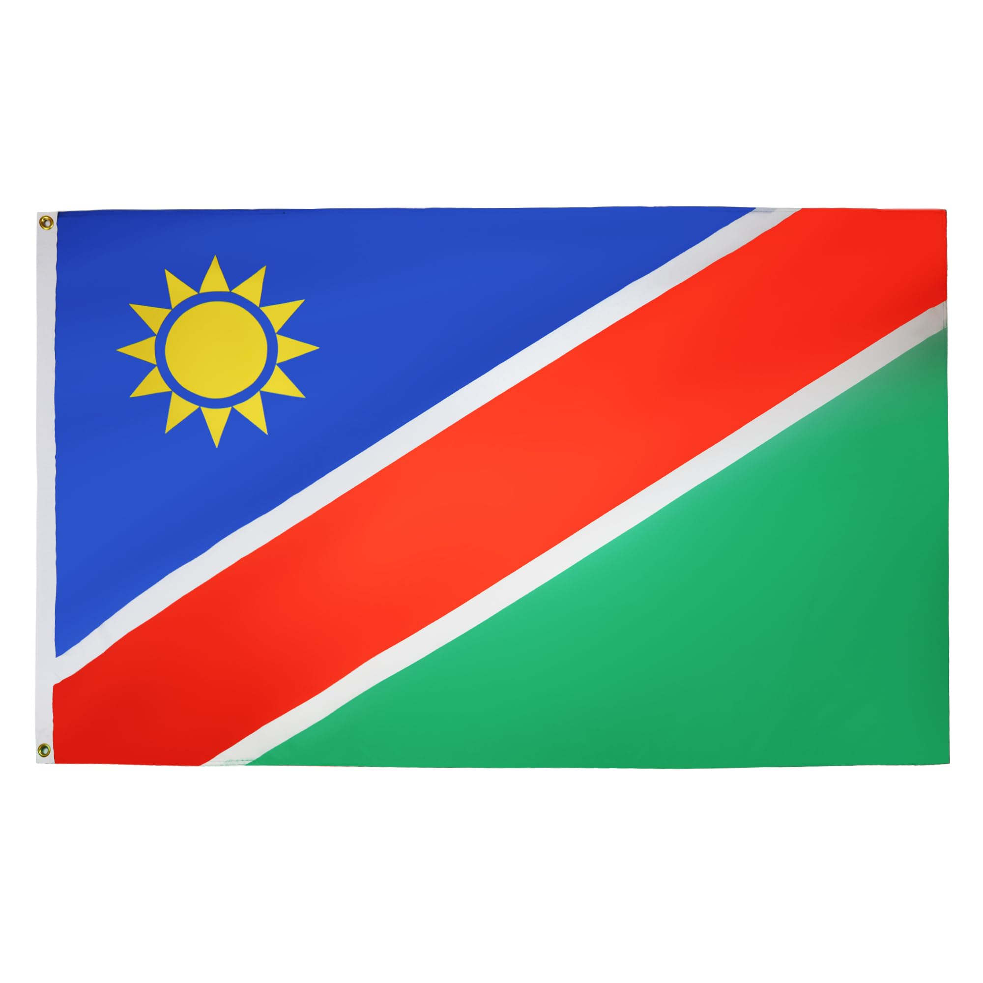

Namibia has a total land area of 823,290 km² and 1,500 km of coastline. This mostly arid country has extremely scarce inland water resources and regularly experiences prolonged periods of drought. Namibia is divided into 14 administrative regions and is one of the least densely populated countries of Africa. The population is estimated at 1.9 million, of whom 32 per cent live in urban areas.

Namibia has a thriving fishing industry thanks to the rich fishing grounds supported by the Benguela Current, one of four upwelling systems that forms the eastern boundary current of the Southern Atlantic Ocean, which is home to abundant stocks of pelagic and demersal fish. The commercial biomass of Namibia’s 200-nautical mile Exclusive Economic Zone contains about 20 different species, consisting mainly of small pelagic fish (sardine, anchovy, horse mackerel, mackerel) and lobster that are found along the shallow coastal waters of the continental shelf, as well as large pelagic species that include adult mackerel, demersal hake and other deep-sea species. However, fish populations on the Namibian coast are prone to sharp natural fluctuations due to both the overall instability of the oceanographic and biological environment as well as to climate change. Some fish populations can even disappear completely for a period of time, and changes in the composition of species can also occur (ATFALCO, 2012).

Namibia has no significant natural freshwater bodies suitable for commercial exploitation. It does share some border rivers with Angola, Zambia, Zimbabwe and Botswana in the Caprivi and Okavango regions, which can provide more than 1 million hectares of river-floodplains with a fishing potential that varies seasonally but ranges between 6,000 and 8,000 tonnes annually, mainly of tilapia. Namibia has no major lakes; its only permanent inland water bodies are man-made reservoirs. Freshwater aquaculture is therefore a challenge (MFMR , 2017).

Inland fisheries yield an estimated 2,000 tonnes annually, of which between 800 and 1,000 tonnes originate at Caprivi. The species caught are mainly catfish, sea bream and tiger fish. Freshwater fish are exported to Botswana, Democratic Republic of the Congo, Malawi, Tanzania and Zambia. The volume of this trade is very low, just 247 tonnes (ATLAFCO, 2012).

The number of licenses for inland aquaculture and mariculture increased to 21 in 2010 and were granted for the cultivation of the following species: abalone, oyster, Pacific oyster, clam, algae, crocodile, tilapia and catfish (ATLAFCO, 2012).

Commercial marine aquaculture is dominated by oyster and abalone production at Walvis Bay, Swakopmund and Lüderitz. Both Pacific oysters (*Crassostrea gigas*) and European oysters (*Ostrea edulis*) are cultivated. Cultivation methods include the use of baskets suspended from rafts, longlines and onshore raceways, in open ocean and in ponds. South African abalone (*Haliotis midae*) is raised at Lüderitz using onshore flow-through tank systems.

Oyster production levels reached approximately 3,500 MTPA in 2016, while mussel production was slightly less than 14 MTPA that same year. In 2016, the markets for Namibia’s farmed oysters consisted of several Asian countries (43 per cent), South Africa (40 per cent) and the domestic market (17 per cent) (Murta y Kibria, 2022).

Despite the abundance of marine fishery resources in Namibia, the country has one of the lowest rates of fish consumption in Africa, an estimated 13.3 kg per capita annually (FAO, 2020). Fish is not part of the traditional diet. On another note, the lack of capacities in the public and private sectors has been identified as one of the main obstacles to the sustainable development of aquaculture in Namibia (ATLAFCO, 2012).

Although the Namibian aquaculture industry remains small, there is potential for it to be a driver of both food security and economic growth in the country. Current governance regulates matters such as public health, environmental protection, animal health and diseases. The strict regulatory requirements for the import of new species limit the growth opportunities that could be achieved with fast-growing non-indigenous species (Angala et al 2022).

**Aquaculture-related institutions include:**

* National Marine Information and Research Centre (NatMIRC)
* Ministery of Fisheries and Marine Resources of Namibia
* Kamutjonga Inland Fisheries Institute (KIFI)
* Department of Agriculture and Natural Resource Sciences, Namibia University of Science and Technology (NUST).
* University of Namibia.

**South Africa** 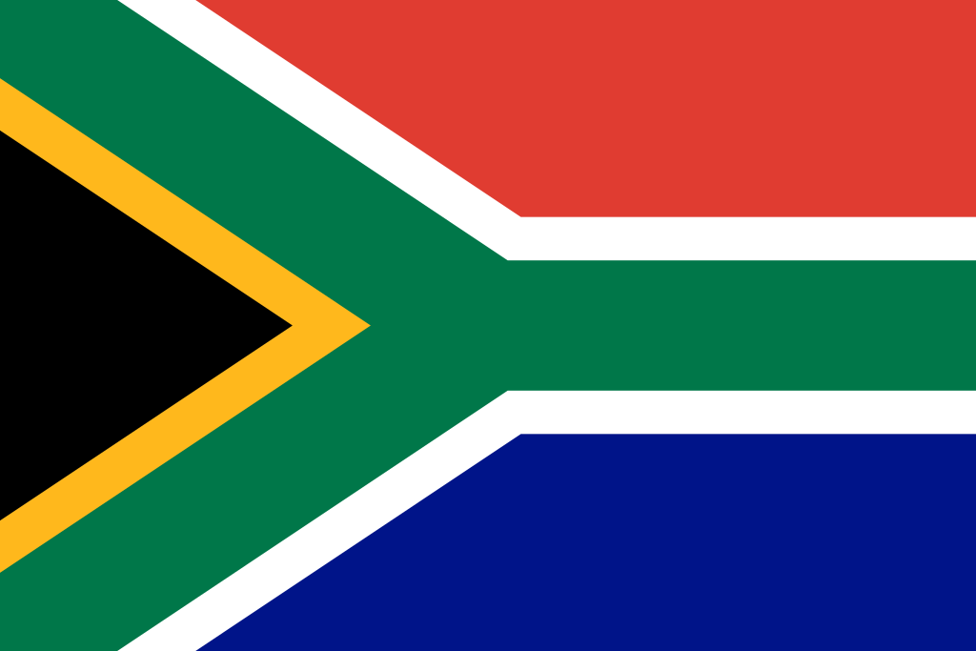

Aquaculture production in South Africa is projected to grow from 6,000 tonnes (live weight equivalent) to around 12,000 tonnes, with growth of close to 90% for the 2020/2030 period (FAO, 2022). Aquaculture production reached 5,500 tonnes in 2016, of which 3,660 were from marine waters. Adequate water supply has been a limiting factor. In addition, about 2,500 tonnes of macroalgae were produced in 2016, which were mostly used as feeds in abalone farming (FAO, 2023). The main freshwater species are trout and tilapia.

The Department of Agriculture, Forestry and Fisheries (DAFF) is main department for the development of aquaculture in South Africa. The Fisheries Management Branch is responsible for its management. According to the DAFF, aquaculture in South Africa is divided into freshwater fish farming and marine aquaculture.

The main freshwater fish species produced in South Africa are trout, tilapia and, to a lesser degree, catfish. The trout sector has largely pioneered fish farming in South Africa. Although trout was introduced in the country for sport fishing in 1890, commercial production did not begin until the 1960s. In 2015, the DAFF registered a total of 189 freshwater and marine farms, the majority of which were freshwater farms using recirculation systems, earthen ponds or canals for cultivation. Oysters and mussels are the main resources cultivated in marine areas, which are farmed using rafts and/or longlines (fishing gear consisting of a long, thick line from which thinner lines are hung every few metres, somewhat akin to the Japanese method, also denominated long-line).

Mariculture operations include the production of abalone, black mussels, oysters, prawns, fish and macroalgae, with abalone being the most important in terms of volume and employment. It is a sector that is developing quickly and it is estimated that South Africa supplies 21 percent of the world market for farmed abalone. Abalone farming is established and concentrated on the coast of the Southern Cape. There are also experimental offshore farms (cage culture), off of Gansbaai for salmon, and further offshore cage culture farms are located off of Mossel Bay for kob (*Argyrosomus sp.*) In 2008, mariculture production consisted of abalone (1,037 tonnes), oysters (227 tonnes), mussels (737 tonnes), prawns (11 tonnes), fish (3 tonnes) and macroalgae (1,834 tonnes). With the introduction of fish farming, it is expected that mariculture production will increase substantially (FAO, 2023).

Fish production ranges from land-based to ocean-based systems. Currently, dark kob (*Argyrosomus japonicus*), spotted grunt (*Pomadasys commersonnii*) and tilapia can be farmed in raceways in land-based open ponds. Sea trout (*Oncorhynchus mykiss*) and Atlantic salmon farming is permitted in Saldanha Bay.

Freshwater species currently being cultivated in South Africa include: rainbow trout, brown trout, crocodiles, ornamental fish, African catfish (*Clarias gariepinus*), Mozambique and Nile tilapia, mud crab and common carp. Rainbow trout, African catfish and Mozambique tilapia are the three most commonly-cultivated species. Different cultivation systems are being used, from net-cage systems in dams to high-density indoor recirculation systems. After reaching a record level of production of 2,200 tonnes in 2003, total freshwater aquaculture production has fallen to around 1,400 tonnes in recent years. (FAO , 2023).

Advanced aquaponics techniques can be a solution to food shortages and can generate new jobs and/or new farmers and producers in South Africa. Fish species cultivated in aquaponics are mainly sea bream, carp and ornamental fish.

South Africa is one of the world’s largest abalone producers and exports high-quality products of the endemic species *Haliotis midae* or *perlemoen*, mainly to Asian markets. There are five endemic species of this gastropod mollusc: the *Haliotis midae, Haliotis* *parva, H. spadicea, H. queketti* and *H. speciosa.* Mussels and oysters are cultivated in raft or floating line systems. They are marketed with the shell, on the half shell, or as frozen meat only. They can be individually quick frozen (IQF) or vacuum packed. Mussels can also be processed into other products, such as chopped garlic mussels. Oyster farming in South Africa uses floating line systems for growing oysters and supplies most of the oysters as live product to South African markets. South African oysters are also exported to Asia (Hong Kong) and Africa (Zambia). Small oyster seed is imported from Chile, Europe, the United States and Namibia.

Kelps and green macroalgae (*Ulva sp.*) are some of South Africa’s most important aquaculture products. They are used as a feed source for abalone, as biofuel and for producing growth stimulants for plants, while *Ulva sp.* is used as an integrated product in abalone farming for supplementary feeding of the abalone. In South Africa, about 7,600 tonnes of seaweed were harvested from the wild, compared to 2,000 tonnes of cultivated seaweed.

Tertiary education in Marine Sciences is quite extensively offered in South Africa, and is a programme at a number of universities, such as:

* University of Cape Town (UCT)
* University of the Witwatersrand
* University of Pretoria
* University of Stellenbosch
* University of Johannesburg (UJ)
* University of Rhodes
* University of KwaZulu-Natal

Other aquaculture-related institutions in South Africa include:

* South African Institute for Aquatic Biodiversity (NRF-SAIAB)
* Aquaculture Association of Southern Africa (AASA)

**Tanzania** 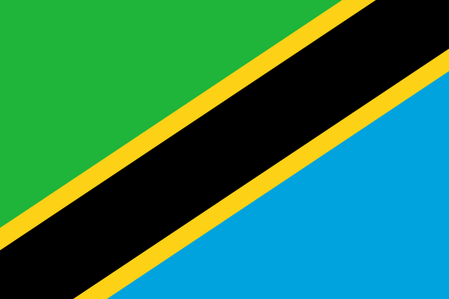

Freshwater aquaculture in Tanzania dates back to 1949, when rainbow trout (*Onchorynchus mykiss*) was introduced into the mountainous regions of the north and south of the country (Rukanga, 2018; Mmanda et al 2020). Due to poor cultivation methods and technologies, growth of the aquaculture sector was slow until the late 1980s (Mallya, 2007). However, the number of fish farms then grew significantly, from 14,100 earthen fish ponds in 2004 to 26,445 in 2019, producing a total of about 18,018.6 MTPA (URT, 2019). It should be noted that 90 per cent of the sector is concentrated in earthen fish ponds and there is considerable potential for investment in other technologies, such as cages, because of the country’s availability of marine and freshwater resources, amounting to 64,000 km² and 64,300 km², respectively. Furthermore, there are 8,000 seaweed farmers with a production of 1,000 tonnes per year (Rukanga, 2018).

Aquaculture activities in Tanzania are regulated by the Fisheries Act, 2003, which was followed by the Fisheries Regulations, 2009, and the development of the National Fisheries Policy of 2015. The director of the Aquaculture Development Division of the Ministry of Agriculture, Livestock and Fisheries is the competent authority for aquaculture in Tanzania, together with the minister and the permanent secretary. Each plays a role in ensuring aquaculture activities are carried out in a respectful and sustainable manner (Rukanga, 2018).

The most commonly farmed species is Nile tilapia (*Oreochromis niloticus*), followed by African catfish (*Clarias gariepinus*) (Mallya, 2007; Chenyambuga et al., 2014). However, for decades, tilapia farming in Tanzania, as in other sub-Saharan countries, has grown very slowly due to a lack of skilled labour, feed supply, and quality seed (=fingerlings) production (Mmanda et al 2020).

Meanwhile, mariculture in Tanzania had its start with Prof. Keto Mshigeni, who promoted and introduced seaweed farming to the country in the 1970s (Msuya et al., 2007). As of 2015, there are about 8,000 seaweed farmers in the country, 90 per cent of whom are women. Cultivated seaweed species include *Eucheuma denticulatum* (*E. spinosum*) and *Kappaphycus alvarezii* (*E. cottonii*). Seaweed farming is an important industry for coastal women and also provides an alternative means of livelihood to the overexploited local fish stocks. In 2015, Tanzania exported about 1,170 tonnes of dried raw seaweed to Spain, the United States, India and China (Rukanga, 2018).

However, Tanzanian seaweed farming has recently stagnated due to different issues, including water quality and seedling shortages (The FishSite: https://seafood.media/Fis/Worldnews/search_brief.asp?l=s&id=108616&ndb=1). On the other hand, by 2015, milkfish (*Chanos chanos*), pearl oyster and prawn farming along the country’s Indian Ocean coastline was producing around 300 tonnes per year (Rukanga, 2018).

A 2017 survey on rural aquaculture indicated that fish farming contributed 13 per cent on average to household incomes and explained 5 per cent of the variation in the same, while 84 per cent of the variation was due to non-fish sources. The majority of fish farmers surveyed (79 per cent) wanted to continue to practice fish farming, while 9 per cent had decided to abandon it and 12 per cent had yet to decide if they would continue (Mulozoki et al 2020). According to Msuya et al. (2022), Tanzania is by far the leading producer of macro seaweed, accounting for 92 per cent of production on the African continent.

Aquaculture-related institutions in Tanzania include:

* Institute of Marine Sciences, University of Dar es Salaam, Zanzibar, Tanzania
* Department of Aquatic Sciences and Fisheries, University of Dar es Salaam, Dar es Salaam, Tanzania.
* Ministry of Agriculture, Livestock and Fisheries, Aquaculture Division, Dodoma,Tanzania
* Kigoma Centre, Tanzania Fisheries Research Institute, Kigoma, Tanzania
* Tanzania Fisheries Research Institute (TAFIRI)
* St. Augustine University Of Tanzania.
* Mzumbe University.
* St John's University of Tanzania.
* St. Joseph University in Tanzania.

**BIBLIOGRAPHY**

Abera, L. 2017. Fisheries production system scenario in Ethiopia. Int. J of Fisheries and Aquatic Studies. 5(1): 79-84

Amenyogbe E, Chen G, Wang Z, Lin M, Lu X, et al.. 2018. A Review of Ghana’s Aquaculture Industry. J Aquac Res Development 9: 545. doi: 10.4172/2155-9546.1000545.

Angala, J, Naftal N.G, Tjipute, M. Asino, H. & Hamukwaya J. 2022. Chapter 23: The Governance of Aquaculture in Namibia as a Vehicle for Food Security and Economic Growth. In: Food Security for African Smallholder Farmers. Sustainability Sciences in Asia and Africa book series (SAFS). 391-405.

ATLAFCO (Ministerial Conference on Fisheries Cooperation among African States Bordering the Atlantic Ocean). 2012. Fisheries and Aquaculture industry in Namibia. Series Report n°2 on the Fisheries and Aquaculture review in the 22 ATLAFCO member countries, 45 pp.

World Bank 2021. Total population – Sub-Saharan Africa, South Africa. https://datos.bancomundial.org/indicator/SP.POP.TOTL?locations=ZG

Blow, P. & Leonard, S. 2008. Estudio de la acuicultura en jaulas: África subsahariana. In M. Halwart, D. Soto and J.R. Arthur (eds). Acuicultura en jaulas – Estudios regionales y panorama mundial. FAO Fisheries Technical Paper. No. 498. Rome, FAO. pp. 199–219.

Boane C, Cruz C. & Saraiva A. 2008. Metazoan parasites of *Cyprinus carpio* L. (Cyprinidae) from Mozambique. Aquaculture 284: 59–61.

Bruno, A. 1987. Situation of Aquaculture in the MEDRAP countries (MEDiterranean Regional Aquaculture Project). GCP/REM/049/ITA. Rome. Corner, R., Fersoy, H. and Crespi, V (eds). 2020. Integrated agri-aquaculture in desert and arid lands: Learning from case studies from Algeria, Egypt and Oman. Fisheries and Aquaculture Circular No. 1195. Cairo, FAO. [https://doi.org/10.4060/ca8610en](https://doi.org/10.4060/ca8610en.).

Chenyambuga, S. W., A. Mwandya, H. A. Lamtane, and N. A. Madalla. 2014. Productivity and marketing of Nile tilapia (Oreochromis niloticus) cultured in ponds of small-scale farmers in Mvomero and Mbarali districts, Tanzania. Livestock Research for Rural Development 26:43

Chirindza, I.A. 2010. A survey of small-scale rural aquaculture in Mozambique. United Nations University Fisheries Training Programme, Iceland [final project]. http://www.unuftp.is/static/fellows/document/isac09prf.pdf.

DAFF, 2018 (Department of Agriculture, Forestry & Fisheries). Operation Phakisa, Unlocking the Oceans Economy througt Aquaculture. Aquaculture year two- Review oct 2014-oct 2016. 44 pp

Estrada, M. 2021. Ficha Sector Marruecos. ICEX España Exportación e Inversiones. Oficina Económica y Comercial de la Embajada de España en Rabat. 8 pp

FAO 2020. FAO Yearbook. Fishery and Aquaculture Statistics 2018. Rome. <https://doi.org/10.4060/cb1213t>

FAO. 2021. GLOBEFISH Highlights - A quarterly update on world seafood markets 1st issue 2021 January–September 2020 Statistics. Globefish Highlights No. 1–2021. Rome. https://doi.org/10.4060/cb4129en

FAO. 2022. The State of World Fisheries and Aquaculture 2022. Towards Blue Transformation. Rome, FAO. <https://doi.org/10.4060/cc0461en>.

FAO 2023. Fishery and Aquaculture Country Profiles South Africa, 2018. Country profile fact sheets. Fisheries and Aquaculture Division [online]. Rome. Updated 5 February 2013 [Cited Wednesday, 6 December 2023]. https://www.fao.org/fishery/es/facp/zaf?lang=en

Hartani, T, 2020. Case studies of the use of non-conventional water in agriculture in support to sustainable agri-aquaculture development in desert and arid lands in NENA region. Algeria case study. In: Corner, R., Fersoy, H. and Crespi, V (eds). 2020. Integrated agri-aquaculture in desert and arid lands: Learning from case studies from Algeria, Egypt and Oman. Fisheries and Aquaculture Circular No. 1195.

KMFRI 2017. Kenya’s Aquaculture Brief: Status, Trends, Challenges and Future Outlook. Kenya Marine and Fisheries Research Institute, Mombasa, Kenya. pp. 12

Lourguioui, H., Brigolin D, Boulahdid M & Pastres R. 2017. A perspective for reducing environmental impacts of mussel culture in Algeria. Int J Life Cycle Assess 22:1266–1277. doi 10.1007/s11367-017-1261-7.

Mallya, Y. J. 2007. The effects of dissolved oxygen on fish growth in aquaculture. The United Nations University, fisheries training programme, Final project, 30. doi:10.1094/PDIS-91-4-0467B

Ministerio de Agricultura, Alimentación y Medio Ambiente (MAGRAMA), 2016. Intercambios Comerciales de Productos pesqueros. España- Egipto. Secretaria General de Pesca. pp. 11

MFMR (Ministry of Fisheries and Marine Resources). 2017. Strategic Plan - 2017/18 - 2021/22. Republic of Namibia. pp. 32

Mmanda, F. Mulokozi, D. Lindberg, J.E., Haldén, A., Mtolera, M. Kitula, R. & T. Lundh, 2020. Fish farming in Tanzania: The availability and nutritive value of local feed ingredients, Journal of Applied Aquaculture, 32:4, 341-360, DOI: 10.1080/10454438.2019.1708836

Moyo N. & Rapatsa M. 2021. A review of the factors affecting tilapia aquaculture production in Southern Africa. Aquaculture 535: 736386.

Msuya, F.E., Shalli, M.S., Sullivan, K., Crawford, B., Tobey, J. and Mmochi, A.J. 2007. A Comparative Economic Analysis of Two Seaweed Farming Methods in Tanzania, UNU – Fisheries Training Programme. University of Rhode Island and the Western Indian Ocean Marine Science Association: Sustainable Coastal Communities and Ecosystem Program, Coastal Resources Center.

Msuya F., Bolton J., Pascal F., Narrain K., Nyonje B. & Cottier-Cokk E. 2022. Seaweed farming in Africa: Current status and future potential. J Appl Phycol 34, 985–1005 https://doi-org.ezproxy2.ucn.cl/10.1007/s10811-021-02676-w.

Mulokozi, D., Mmanda, F.P., Onyango, P., Lundh, T., Tamatamah, R.,& H. Berg, 2020. Rural aquaculture: Assessment of its contribution to household income and farmers’ perception in selected districts, Tanzania, Aquaculture Economics & Management, 24:4, 387-405, DOI: 10.1080/13657305.2020.1725687.

Murta, G. & G. Kibria. 2017. An emerging shellfish farming industry in Namibia. https://www.globalseafood.org/advocate/emerging-shellfish-farming-industry-namibia/

Natea, G. 2019. Aquaculture potential, status, constraints and future prospects in Ethiopia: a review. Int. J. Adv. Res. 7(1), 336-343.

Nyandat, B. 2007. Analysis of feeds and fertilizers for sustainable aquaculture development in Kenya. In M.R. Hasan, T. Hecht, S.S. De Silva and A.G.J. Tacon (eds). Study and analysis of feeds and fertilizers for sustainable aquaculture development. FAO Fisheries Technical Paper. No. 497. Rome, FAO. pp. 423–436.

Obura, D. O., Bandeira, S. O., Bodin, N., Burgener, V., Braulik, G., Chassot, E., Ternon, J.-F. 2019. The Northern Mozambique Channel. World Seas: An Environmental Evaluation, 75–99. doi:10.1016/b978-0-08-100853-9.00003-8

Picker, M., Griffiths, C., 2011. Alien and invasive animals - a South African perspective. Struik, Cape Town.

Rukanga, J.J., 2018. Evaluation of aquaculture development in Tanzania. Nations University Fisheries Training Programme, Iceland [final project]. http://www.unuftp.is/static/fellows/document/janeth16aprf.pdf

Rurangwa E, Agyakwah SK, Boon H, Bolman BC. 2015. Development of aquaculture in Ghana, analysis of the fish value chain and potential business cases. IMARES report C021/15.

Secretaria de Estado y Comercio, 2021. Informe Económico y Social. Sudáfrica. Elaborado por la oficina Económica y comercial de España en Johanesburgo.

Sany-Eldine, A. & Baromh, M. 2021. Development of the Fisheries and Aquaculture Sector in Egypt. Aquafeed International 24(2):46-49.

Tembe J, 2014. Mozambique. In: Towards the implementation of the SSF Guidelines in the Southern Africa and Indian Ocean region December 2016, Mauritius. Indian Ocean Commission. Pp 30-31.

URT (United Republic of Tanzania). 2019. United Republic of Tanzania: Budget Speech 2019/2020. Ministry of Livestock and fisheries, Dodoma, Tanzania

Yalew, A. Dejen, E. & Spliethoff, P. 2015. Business Opportunities Report Aquaculture #10 in the series written for the "Ethiopian Netherlands business event 5-6 November 2015, Rijswijk, Netherlands.